2022 MAACS ANNUAL GOLF TOURNAMENT

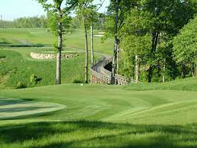
Tee off the 2022 MAACS Conference at our annual golf tournament to be held this year at Cranberry Highlands Golf Course on July 26th. A special thanks to Oozle Media for being our tournament sponsor again this year.
The tournament will be a “scramble” format with tee times starting at 1:00 PM. The cost is $125/per golfer or $500 for foursome, which will cover greens fee, cart, dinner, drinks, prizes and an afternoon of fun with fellow career school leaders and colleagues. Championship honors and prizes will be awarded at the dinner following the round. Participation is limited to the first 32 golfers to register. Please fill out the registration form below and return it to Aaron Shenck with your check made payable to “MAACS.” If you have any questions, please contact Aaron Shenck at aaron@maacs.us.

Registration Information:
Golfer(s) Name(s):
________________________________________________________________________________________________________________________________________________________________________________________________________________________________________________________________________________________________________________________
School or company golfers are affiliated with:
______________________________________________________________________________
Contact email and cell phone:
_____________________________________________________________________________
Credit card number and expiration
______________________________________________________________________________
Return this form by email to aaron@maacs.us with credit card information, or mail your form and $125 per golfer with check made payable to “MAACS” to: MAACS, PO Box 152, Lemoyne, PA 17043

